HANDS-ON 4 - Async JavaScript, Fetch API & API Integration

Task 1: Promises and async/await
45. Write a function fetchUser(id) that calls fetch('https://jsonplaceholder.typicode.com/users/' + id) and returns a Promise. Chain .then() to parse the JSON and log the user's name.
index.html
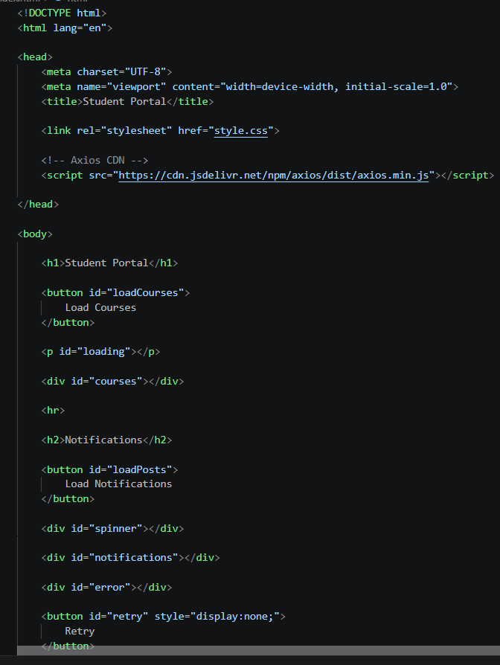
style.css
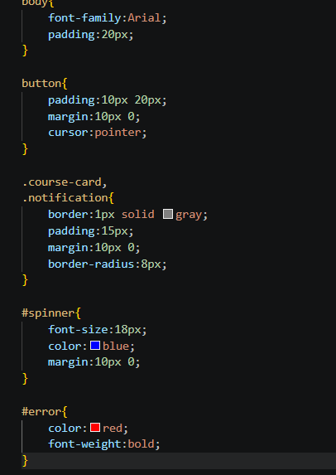
app.js
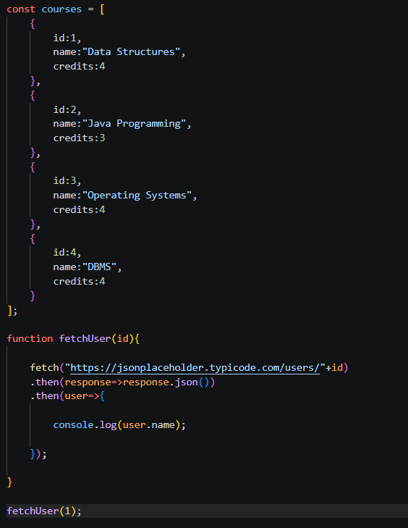
46. Rewrite the same function using async/await and try/catch.
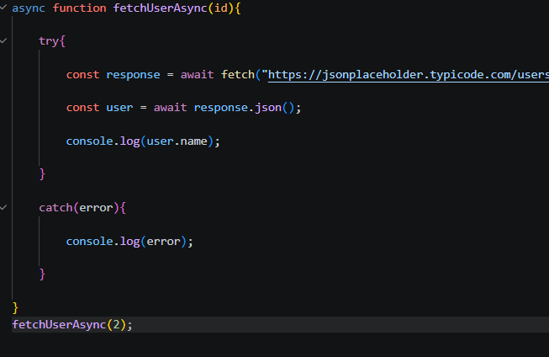

47. Write a function fetchAllCourses() that simulates a 1-second network delay using new Promise(resolve => setTimeout(resolve, 1000)) and then returns your local course array.
48. Call fetchAllCourses() and render the course cards only after the promise resolves. Show a 'Loading courses...' message while waiting.
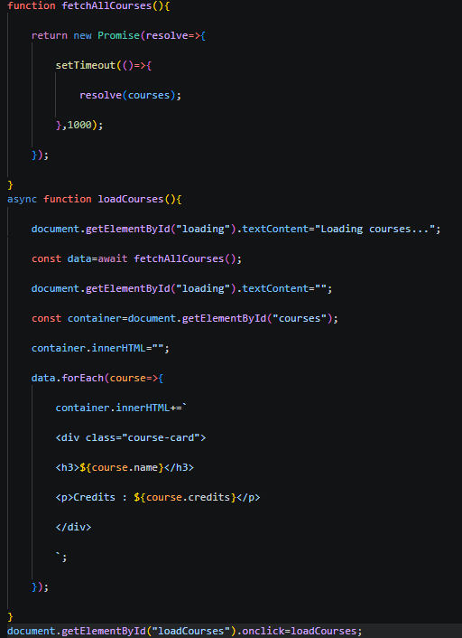
49. Demonstrate Promise.all(): fetch user ID 1 and user ID 2 simultaneously and log both names when both requests complete.
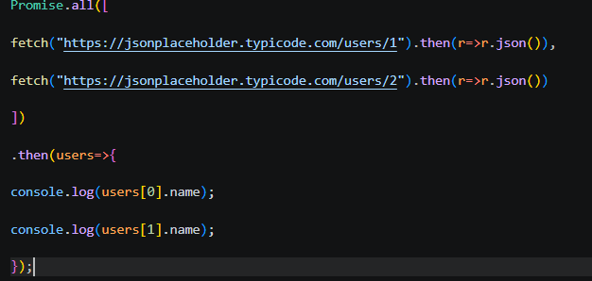
Task 2: Fetch API with Error Handling
50. Create a reusable async function apiFetch(url) that fetches data, checks response.ok, throws a descriptive Error if not ok, and returns the parsed JSON.
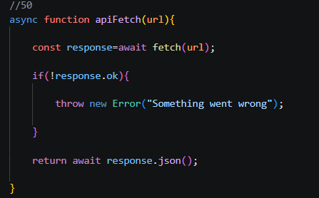
51. Use apiFetch to load posts from /posts and render them as notification cards in a new on the page.
52. Add a loading spinner (a simple animated CSS div or a text indicator) that appears while the fetch is in-progress and disappears when data loads.
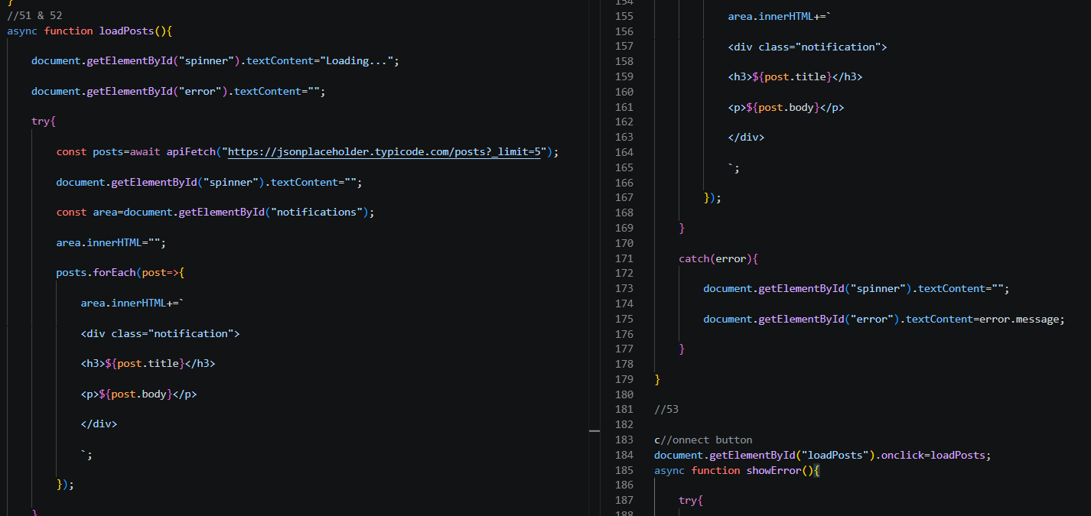
53. Simulate a 404 error by calling apiFetch with a bad URL (e.g., /nonexistent). Display a user-friendly error message in the UI — never just log to console.
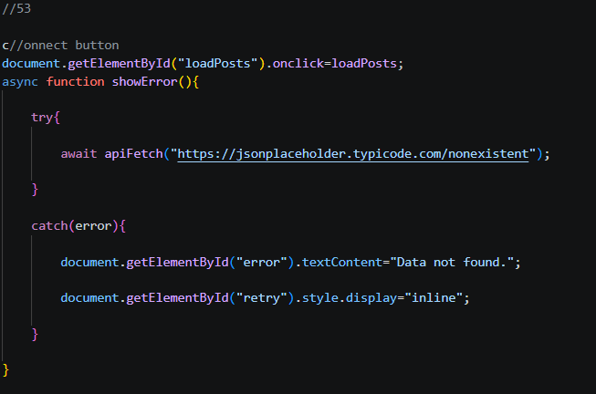
54. Add a Retry button that appears when an error occurs. On click, it re-calls the fetch function and re renders the section.
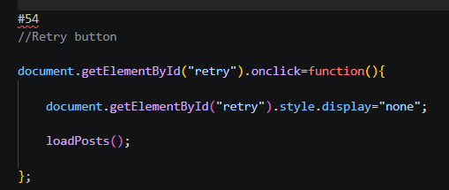
55. Add Axios via CDN in your HTML: .
56. Rewrite the apiFetch function using axios.get(url). Note that Axios: (a) automatically parses JSON, (b) throws on non-2xx responses by default — no need to check response.ok manually.
57. Use axios.get with a params object: axios.get('/posts', { params: { userId: 1 } }) to fetch posts belonging to user 1.
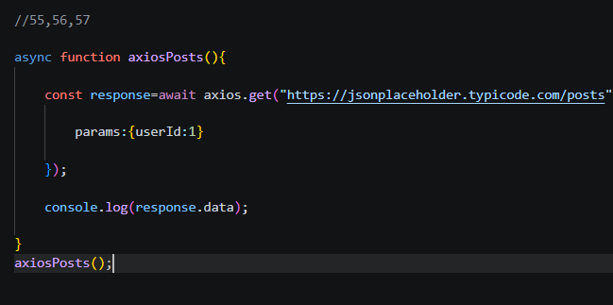
58. Add a request interceptor using axios.interceptors.request.use() that logs 'API call started: ' before every request.
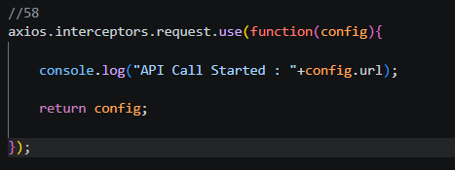
59. Compare: write a side-by-side comment in your code listing three differences between fetch and axios.
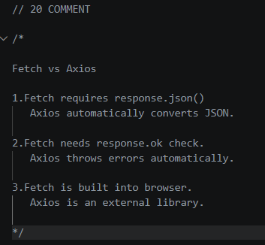

OUTPUT:
